(a) Because the last component of h is the second to last square, and no matter what you roll, 1 to N, you will always move to the last space, so its guaranteed to be 1. as in 1 move to get to the end of the space.
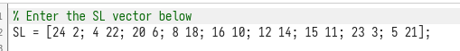

(b) This is approaching
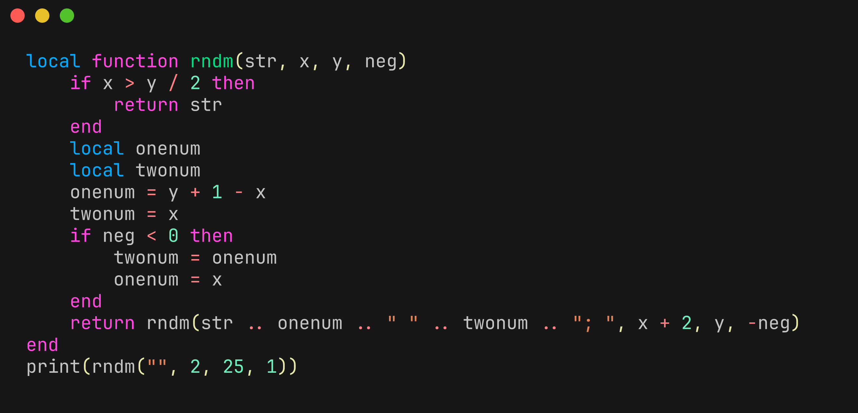
game theory than math, but originally I had made a small lua script to create the small sl vector.

It returned the following output:
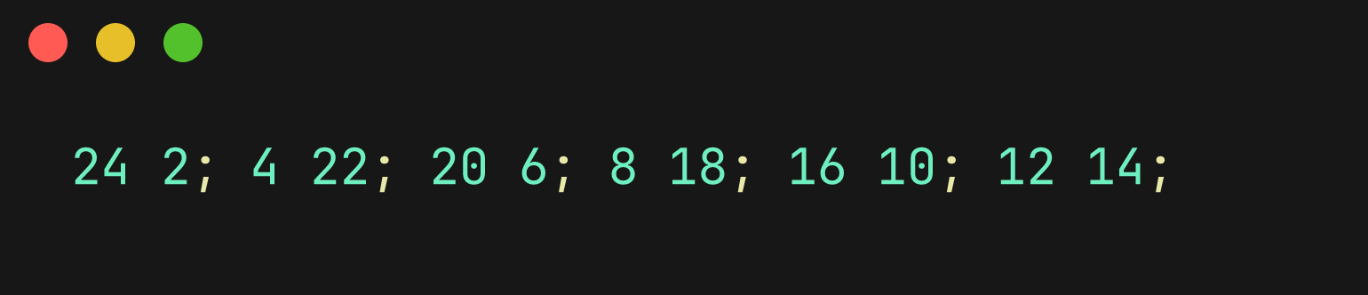
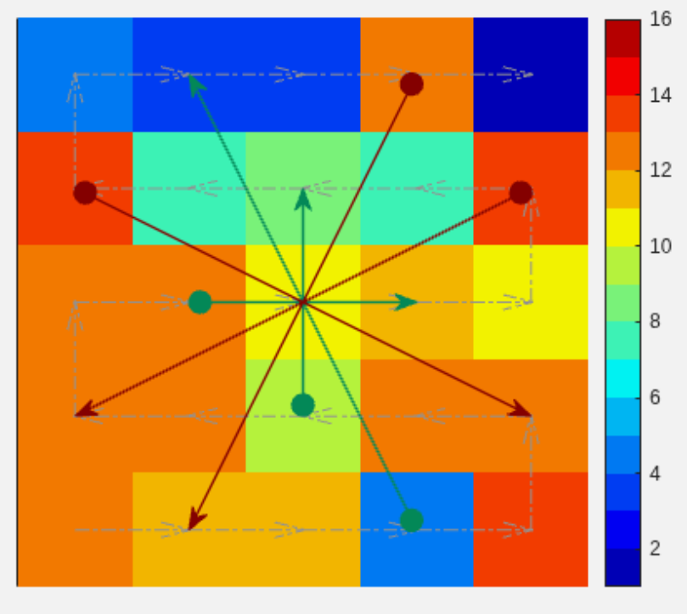
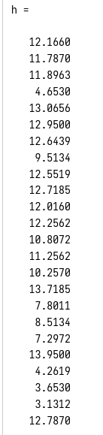
this is six snakes and ladders, I like that the last space is instant death to the shadow realm, it adds a spicyness, like you can do everything right and still fail. And being able to win early is good. I also like how the snakes are overall worse to get hit by then the ladders overall. I think red is good for this game.
(c) 12.1160, its the first value of h, corresponding to how many moves is likely to happen at first space.
(d)
for i= 1:height(SL)
s(SL(i,1)) = 0;
end
Its 3 lines of code, just add it after s, no problems at all.

add this line after. The way to understand this is by first looking at the recursive formula. Which is h = s + ph. The s just adds after moving to a space, in the case theoretically if you made one of the numbers 0 in the s index vector, it would just not add the extra move as a move. This is how the snake works.

Then we can move it back into our real formula for h, with the understanding out of the way.

PART 2
(a) done
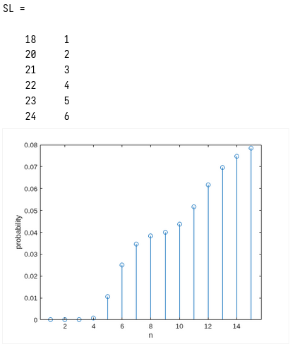
(b) code below next page, output on the right.
